**OPTIMIZING USER, GROUP, AND ROLE MANAGEMENT WITH ACCESS CONTROL AND WORKFLOWS**

**NAAN MUDALVAN PROJECT TEAM**

**ID:**

**NM2025TMID17787**

**Team Leader : HEMACHANDRAN N**

**Team member : INBAM R**

**Team member : JAHIR HUSSAN A**

**Team member : JANANI K**

**ST.JOSEPH’S COLLEGE (ARTS & SCIENCE)**

**INDEX**

1. Introduction
2. Abstract
3. Problem statement
4. Solution
5. Practical use
6. Knowledge gained
7. Milestone 1: CREATE USERS
8. Milestone 2: CREATE GROUPS
9. Milestone 3: CREATE ROLES
10. Milestone 4: CREATION OF TABLE

11.Milestone 5: ASSIGNED USERS TO GROUPS

1. Milestone 6: ASSIGNED A ROLES TO USERS
2. Milestone 7: TABLE ACCESS TO APPLICATION
3. Milestone 8: CREATION OF ACCESS LIST
4. Milestone 9: CREATE A FLOW TO ASSIGN

OPERATIONS

1. Conclusion

**INTRODUCTION**

In the collaborative environment of a small project management team, effective task management is paramount to achieving project goals. A common challenge, however, is the lack of a structured system for defining who can do what, leading to confusion, inefficiency, and a lack of accountability. This problem is particularly evident in our scenario involving a twoperson team: Project Manager Alice and Team Member Bob. The absence of clear role definitions, access controls, and a standardized workflow means that tasks may be poorly assigned, progress is difficult to track, and final project outcomes are at risk. This document outlines a solution to this problem by implementing a robust framework for user, group, and role management, coupled with a systematic approach to access control and a defined task workflow. The goal is to create a transparent, efficient, and accountable system that empowers both team members to fulfill their specific responsibilities without confusion or overlap, ensuring projects are completed on time and within scope.

# PROBLEM STATEMENT

In a small project management team consisting of a

Project Manager (Alice) and a Team Member (Bob), there is a need to efficiently manage project tasks and ensure accountability throughout the project lifecycle.

The current system lacks clear role definitions, access controls, and a structured workflow, leading to confusion regarding task assignments and progress

tracking.

**SOLUTION**

To optimize user, group, and role management with access control and workflows for the project management team, a Role-Based Access Control (RBAC) model with a defined Task Management Workflow should be implemented. This approach ensures that users (Alice and

Bob) have specific permissions based on their roles, and all tasks follow a clear, sequential process.

**PRACTICAL USE**

* **Clarity:** **Alice** knows she is the sole owner of project setup and final approval, while **Bob** knows his responsibility is to execute and update his assigned tasks.
* **Accountability:** Each task's history shows who made the last update and when, providing a clear audit trail.
* **Efficiency:** The structured workflow eliminates guesswork. **Bob** knows exactly what to do with a task at each stage, and

**Alice** can quickly see what's ready for her review.

# KNOWLEDGE GAINED

By implementing this system, the team gains a deeper understanding of **Role-Based Access Control (RBAC)** and **workflow management**. They learn that:

* **RBAC** isn't just about security; it's a powerful tool for defining responsibilities and clarifying roles.
* A **well-defined workflow** is essential for standardizing processes and ensuring consistency, even in a small team.
* Technology solutions (like project management software) are most effective when they are configured to support an organization's specific roles and processes, not just used out of the box.

# MILESTONE 1: CREATE USERS

**Go to the official ServiceNow Developer portal:** [**https://developer.servicenow.com**](https://developer.servicenow.com/?utm_source=chatgpt.com) **and create a developer account.**

 

* Open service now
* Click on All >> search for users
* Select Users under system security
* Click on new
* Fill the following details to create a new user
* Click on submit

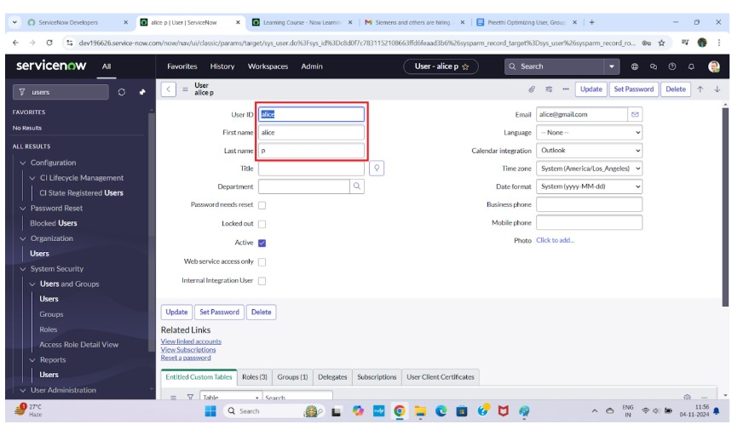

# MILSTONE 2: CREATE GROUPS

**Log in to your ServiceNow instance and go to the**

**Application Navigator.** 

* Open service now.
* Click on All >> search for groups
* Select groups under system security
* Click on new
* Fill the following details to create a new group
* Click on submit

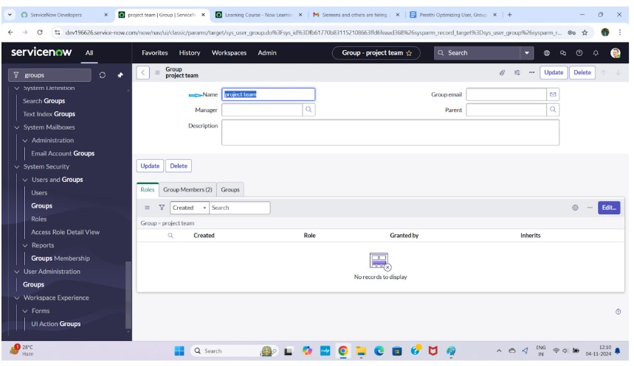

# MILSTONE 3: CREATE ROLES

* Open service now.
* Click on All >> search for roles
* Select roles under system security
* Click on new
* Fill the following details to create a new role
* Click on submit

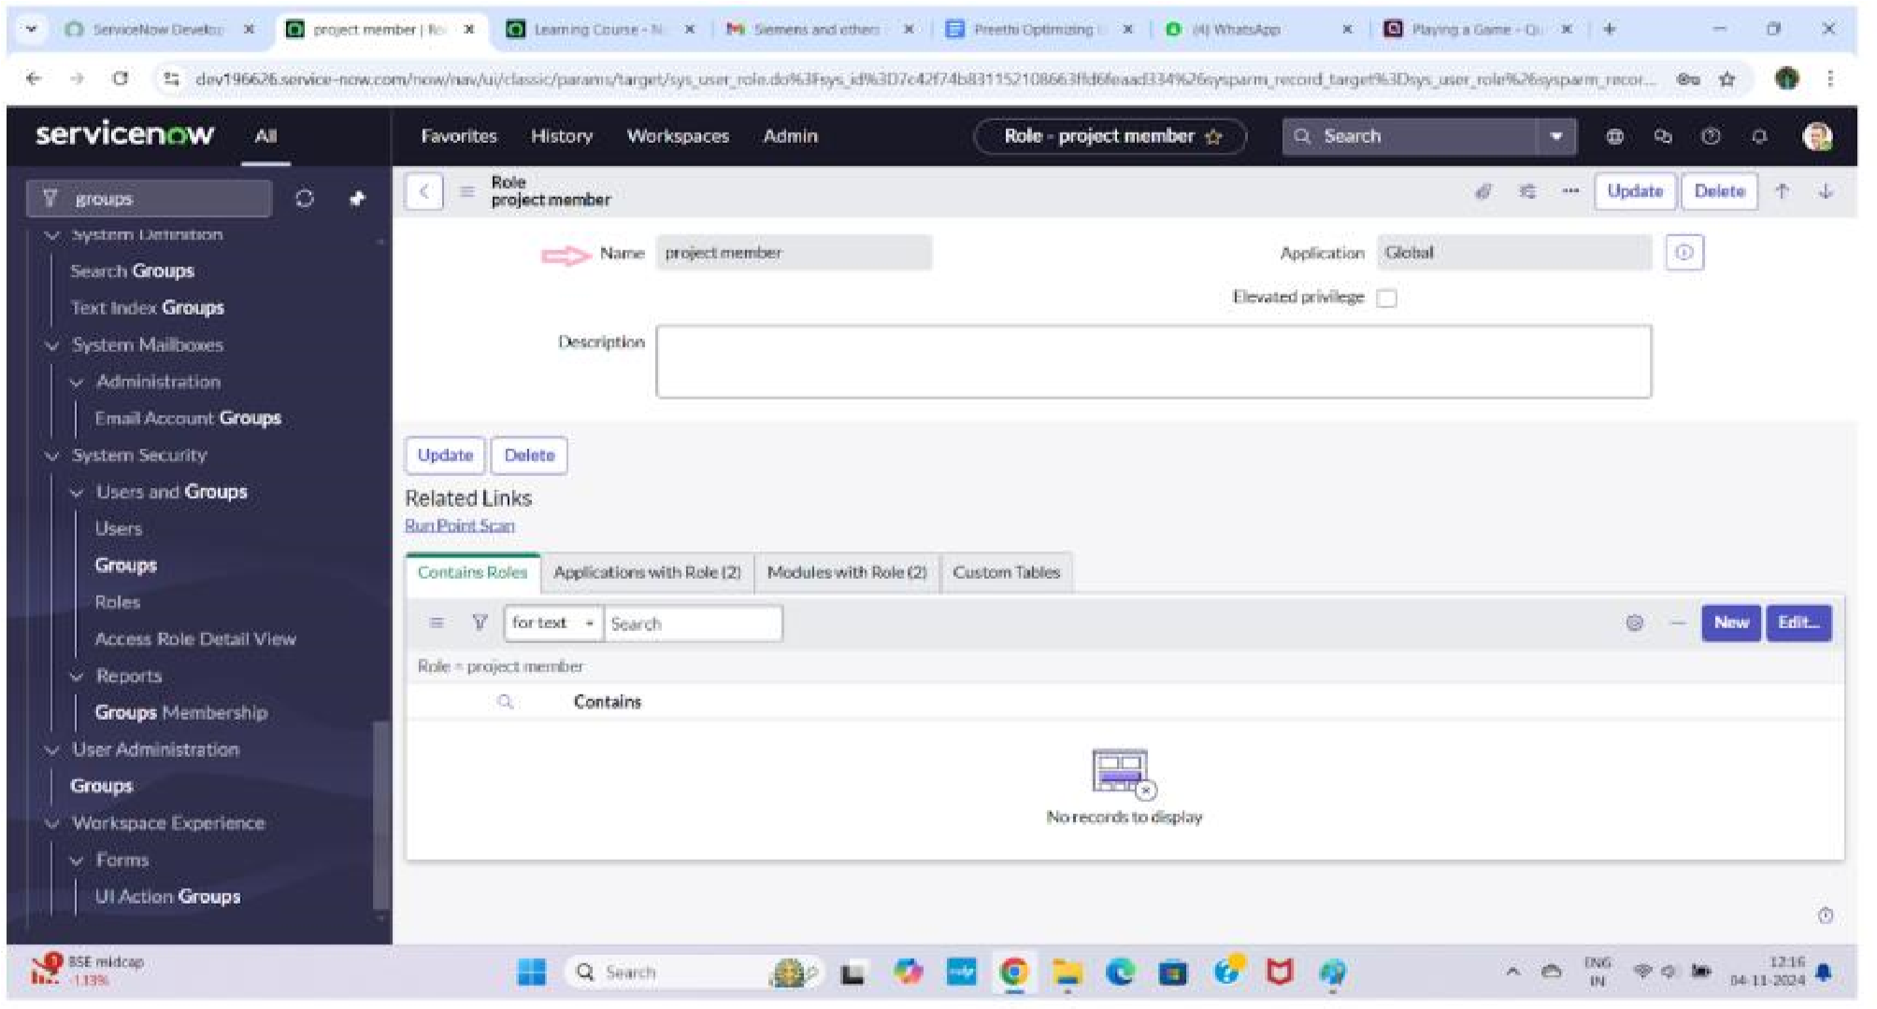

# MILSTONE 4: CREATION OF TABLE

* Open service now.
* Click on All >> search for tables
* Select tables under system definition
* Click on new
* Fill the following details to create a new table

Label : project table

Check the boxes Create module & Create mobile module

* Under new menu name : project table
* Under table columns give the columns

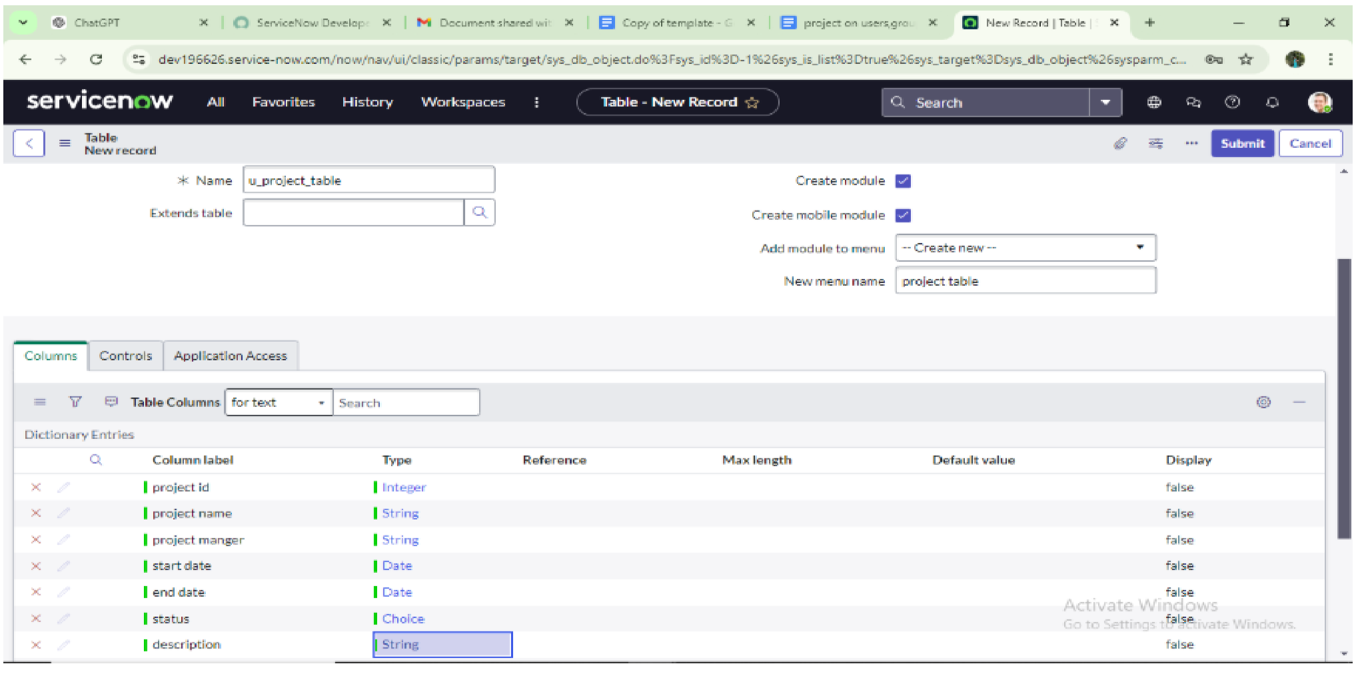

# MILSTONE 5: ASSIGNED USERS TO GROUPS

Assign users to project team group

* Open service now.
* Click on All >> search for groups
* Select tables under system definition
* Select the project team group
* Under group members
* Click on edit
* Select alice p and bob p and save

 

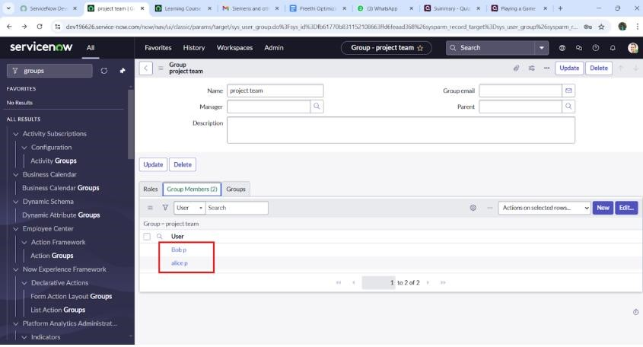

**ASSIGNED A ROLES TO USERS**

* Open Servicenow.Click On All >> Search For User
* Select Tables Under System Definition
* Select The Project Manager User
* Under Project Manager
* Click On Edit
* Select Project Member And Save
* Click On Edit Add Project Table Role
* Click On Save And Update The Form

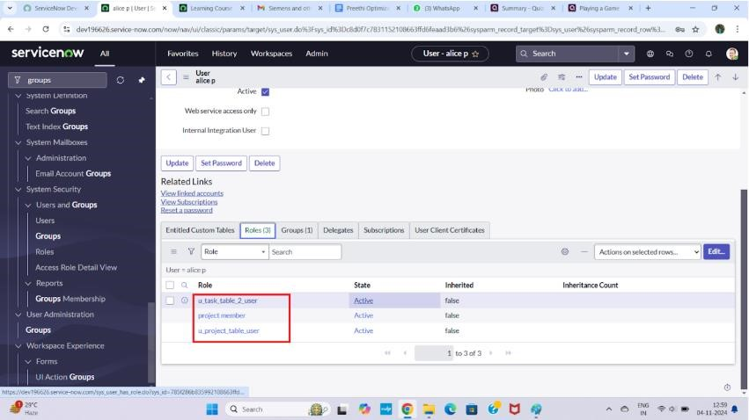

# TABLE ACCESS TO APPLICATION

* while creating a table it automatically create a application and module for that table
* Go to application navigator search for search project table application
* Click on edit module
* Give project member roles to that application • Search for task table2 and click on edit application.
* Give the project member and team member role for task table 2 application

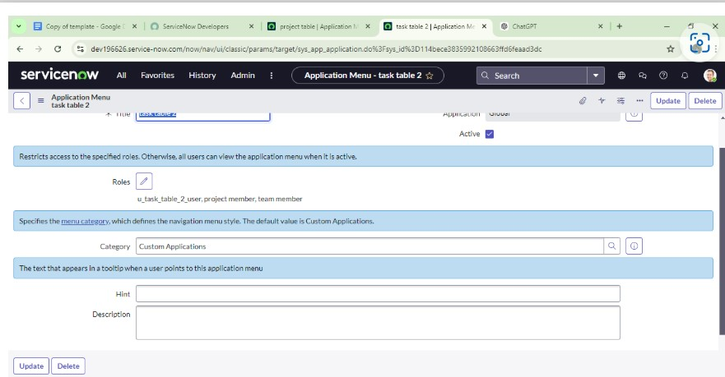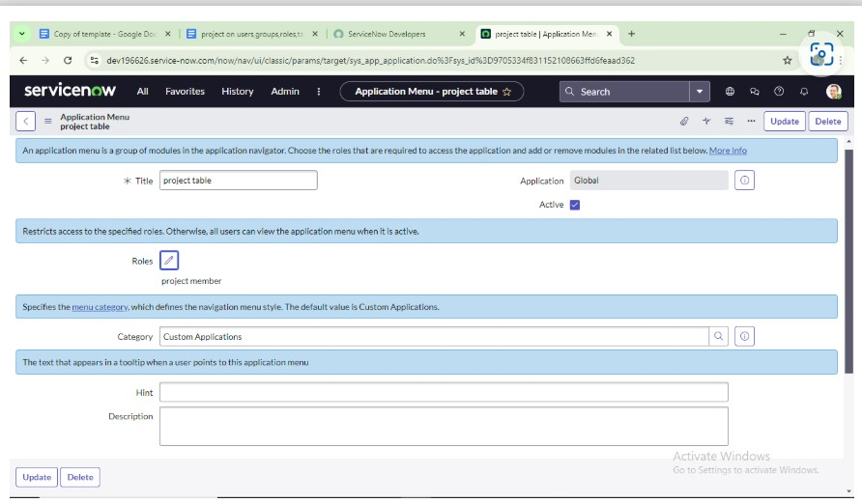

# CREATION OF ACCESS CONTROL LIST

* Open service now.
* Click on All >> search for ACL
* Select Access Control(ACL) under system security
* Click on elevate role
* Click on new
* Fill the following details to create a new ACL

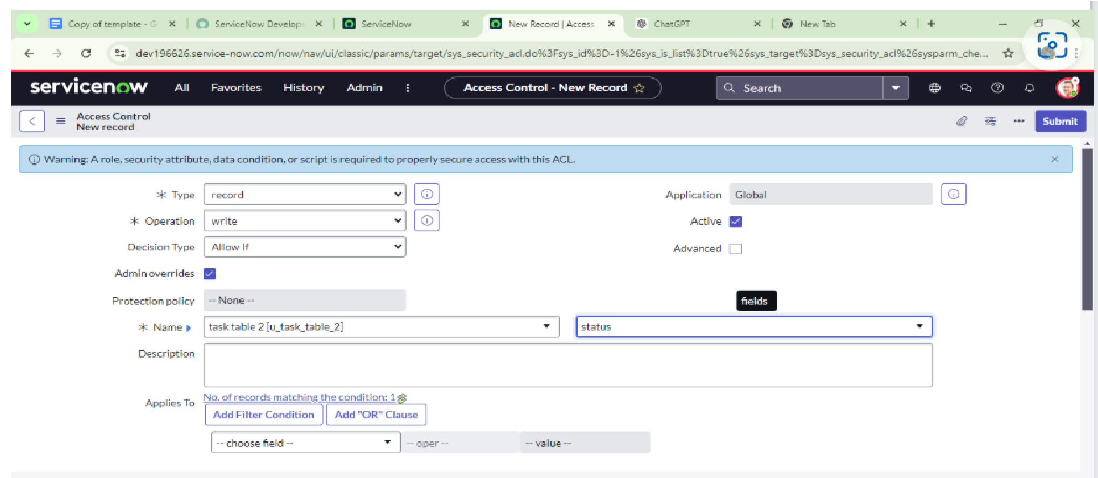

* Scroll down under requires role
* Double click on insert a new row
* Give task table and team member role
* Click on submit
* Similarly create 4 acl for the following fields

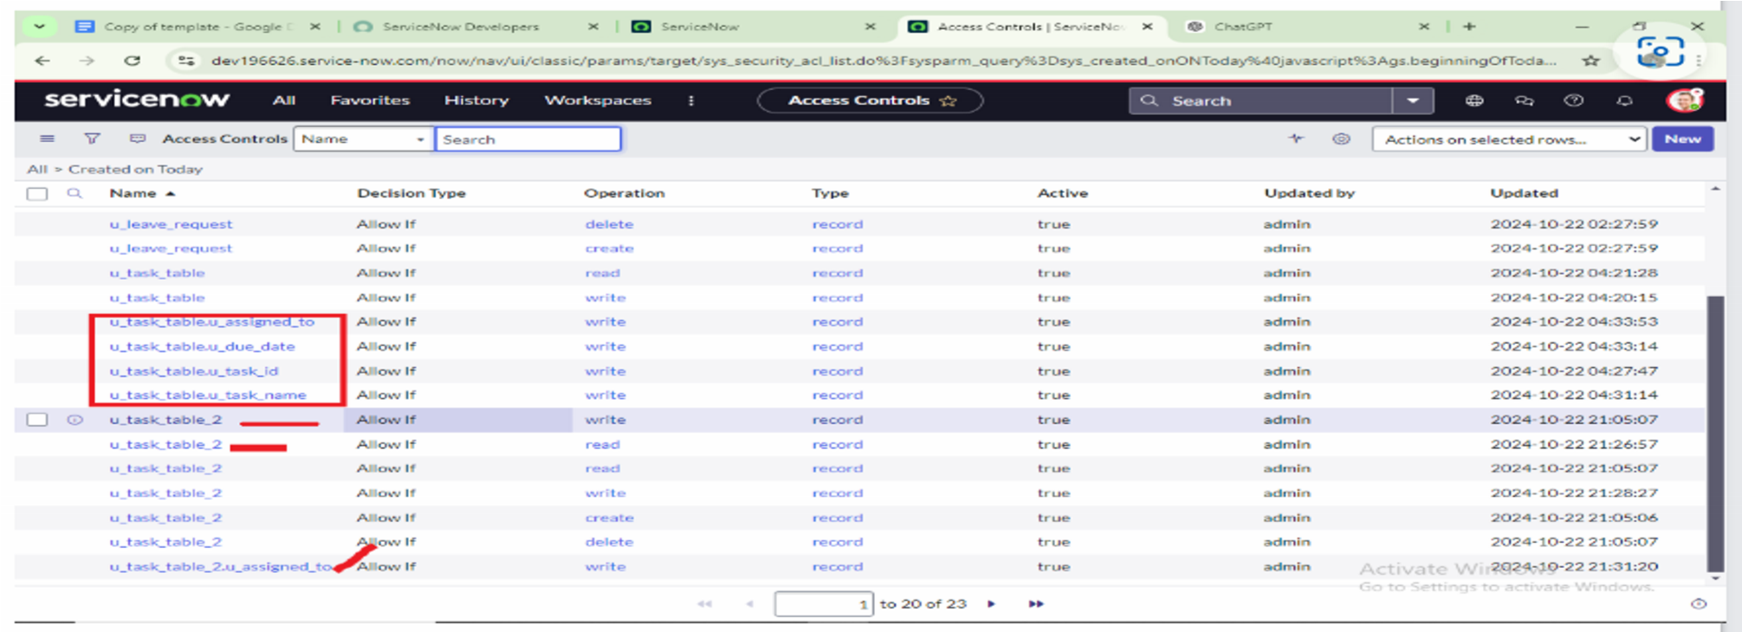

* Click on profile on top right side
* Click on impersonate user
* Select bob user
* Go to all and select task table2 in the application menu bar
* Comment and status fields are have the edit access

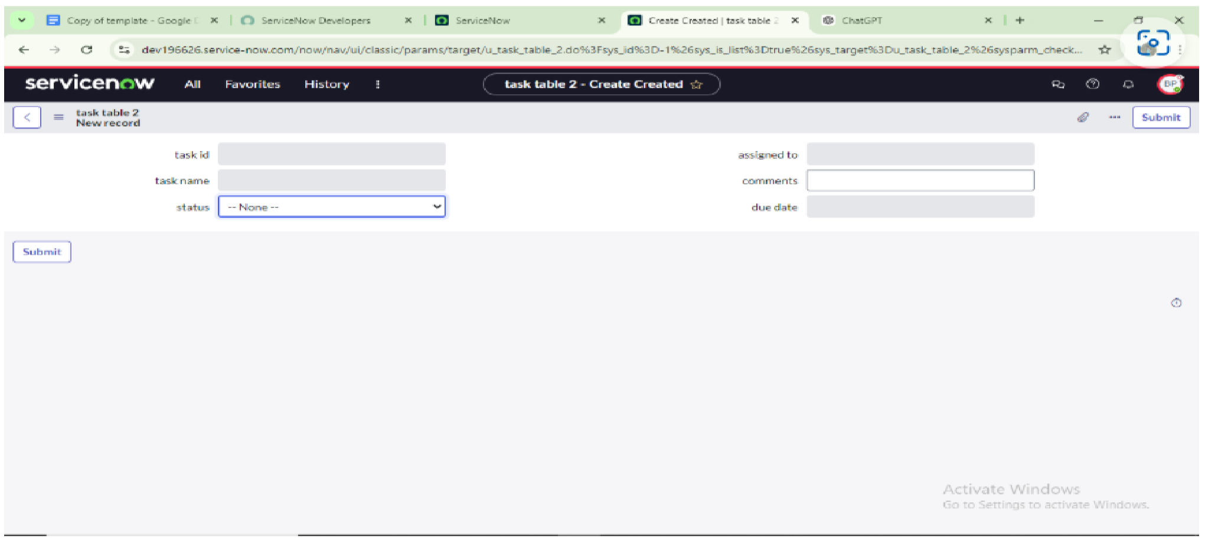

# MILSTONE 9: CREATE A FLOW TO ASSIGN OPERATIONS

* Open service now.
* Click on All >> search for Flow Designer
* Click on Flow Designer under Process Automation.
* After opening Flow Designer Click on new and select Flow.
* Under Flow properties Give Flow Name as “ task table”.
* Application should be Global.

•

Click build flow.

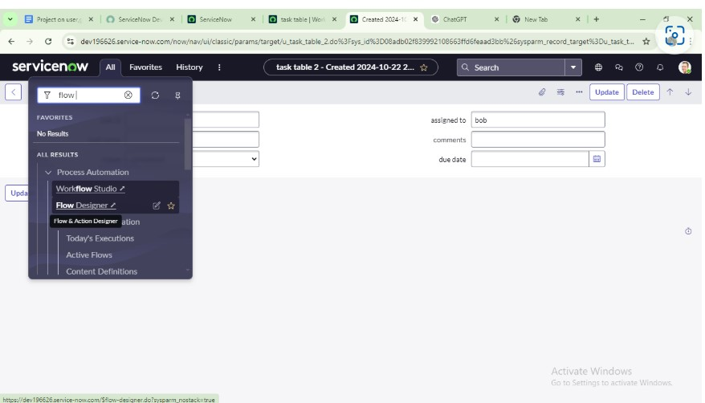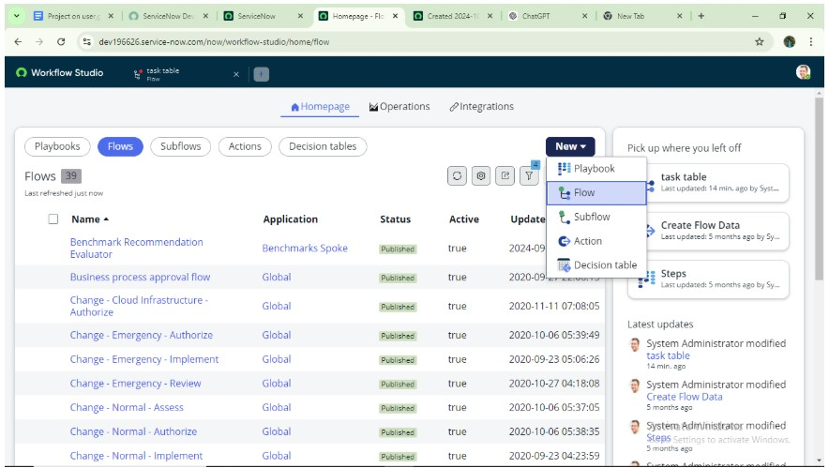

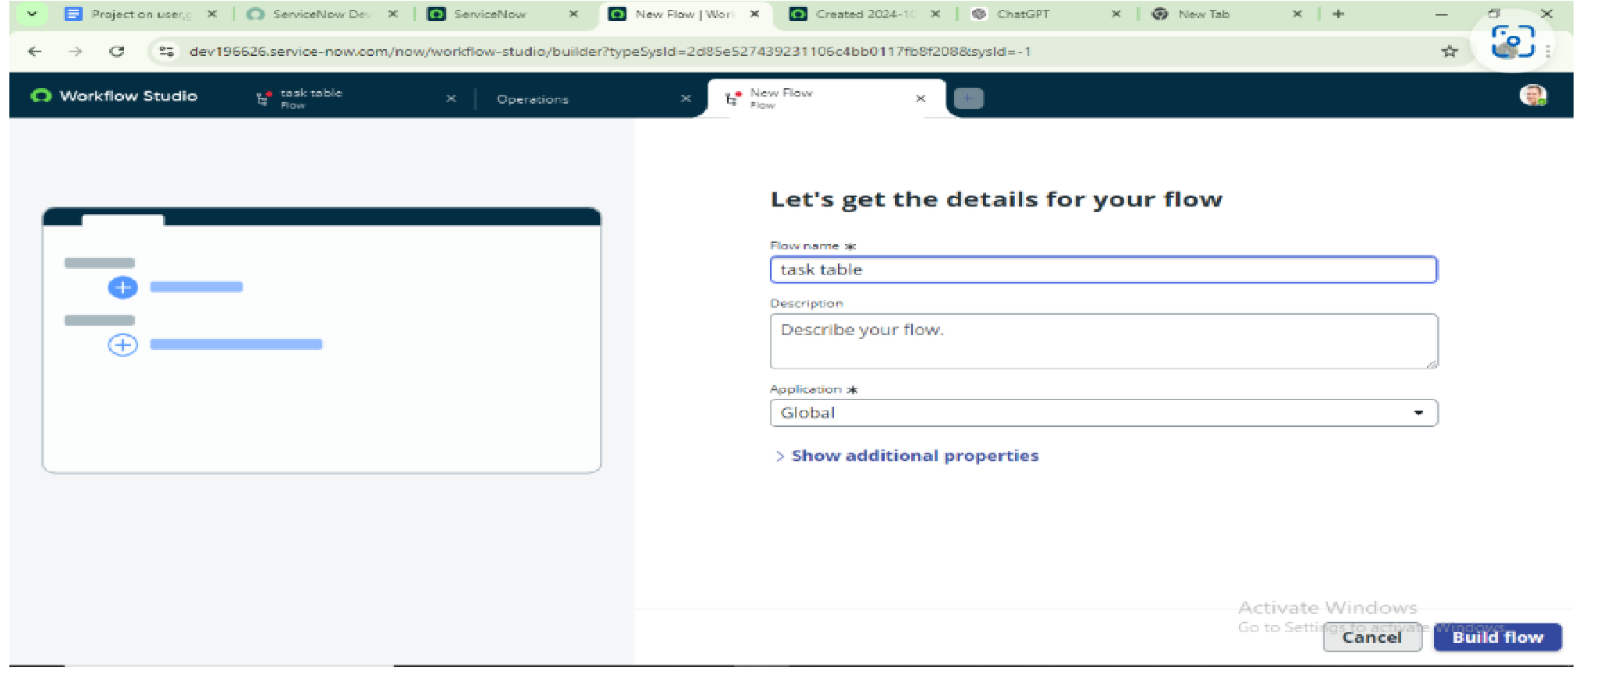

**next step:**

* Click on Add a trigger
* Select the trigger in that Search for “create record” and select that.
* Give the table name as “ task table ”.
* Give the Condition as Field : status Operator :is Value : in progress
  + Field : comments Operator :is Value : feedback
  + Field : assigned to Operator :is Value : bob
* After that click on Done

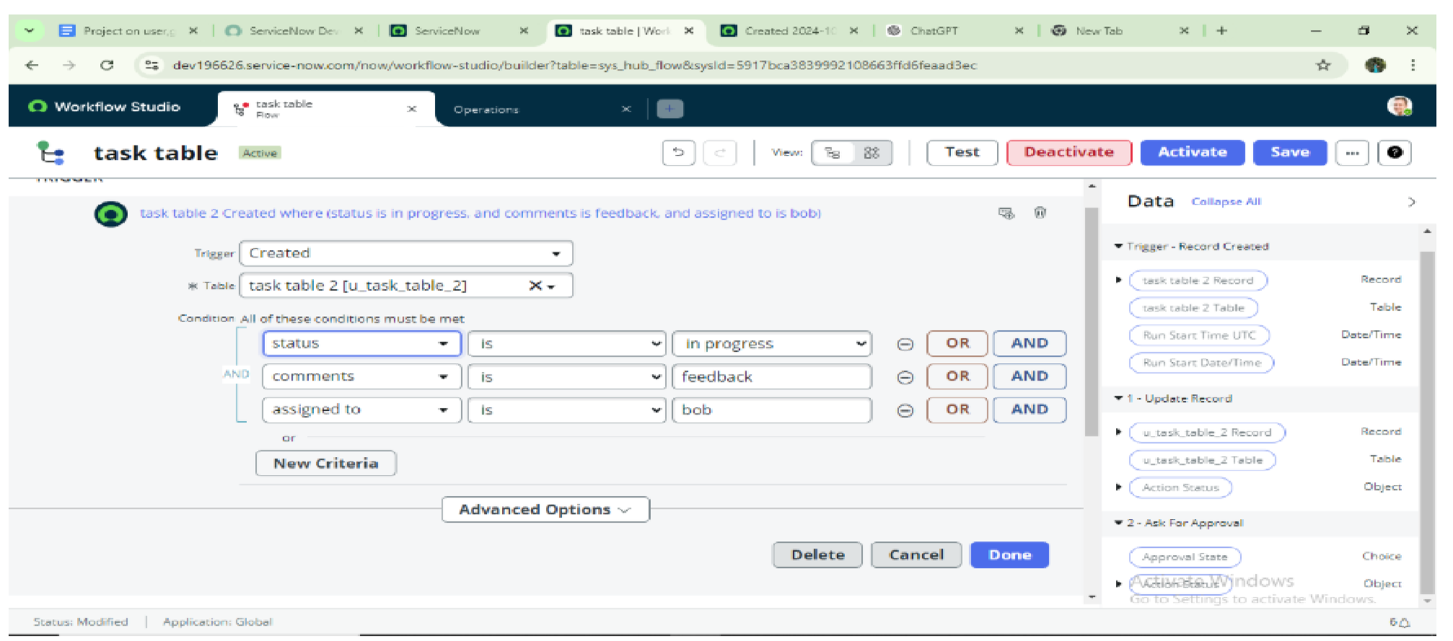

**Next step:**

* Click on Add an action.
* Select action in that ,search for “ update records”.
* In Record field drag the fields from the data navigation from Right Side(Data pill)
* Table will be auto assigned after that
* Add fields as “status” and value as “completed”
* Click on Done.

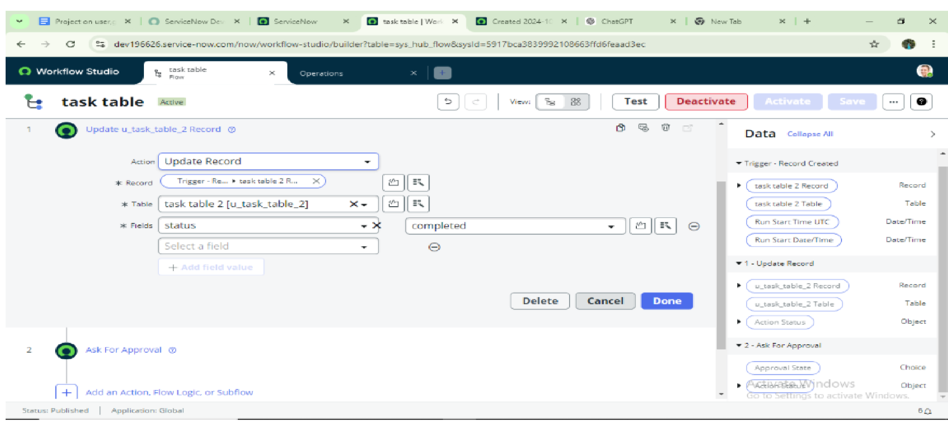

# Next step:

* Now under Actions.
* Click on Add an action.
* Select action in that ,search for “ ask for approval ”.
* In Record field drag the fields from the data navigation from Right side
* Table will be auto assigned after that
* Give the approve field as “ status” • Give approver as alice p
* Click on Done.

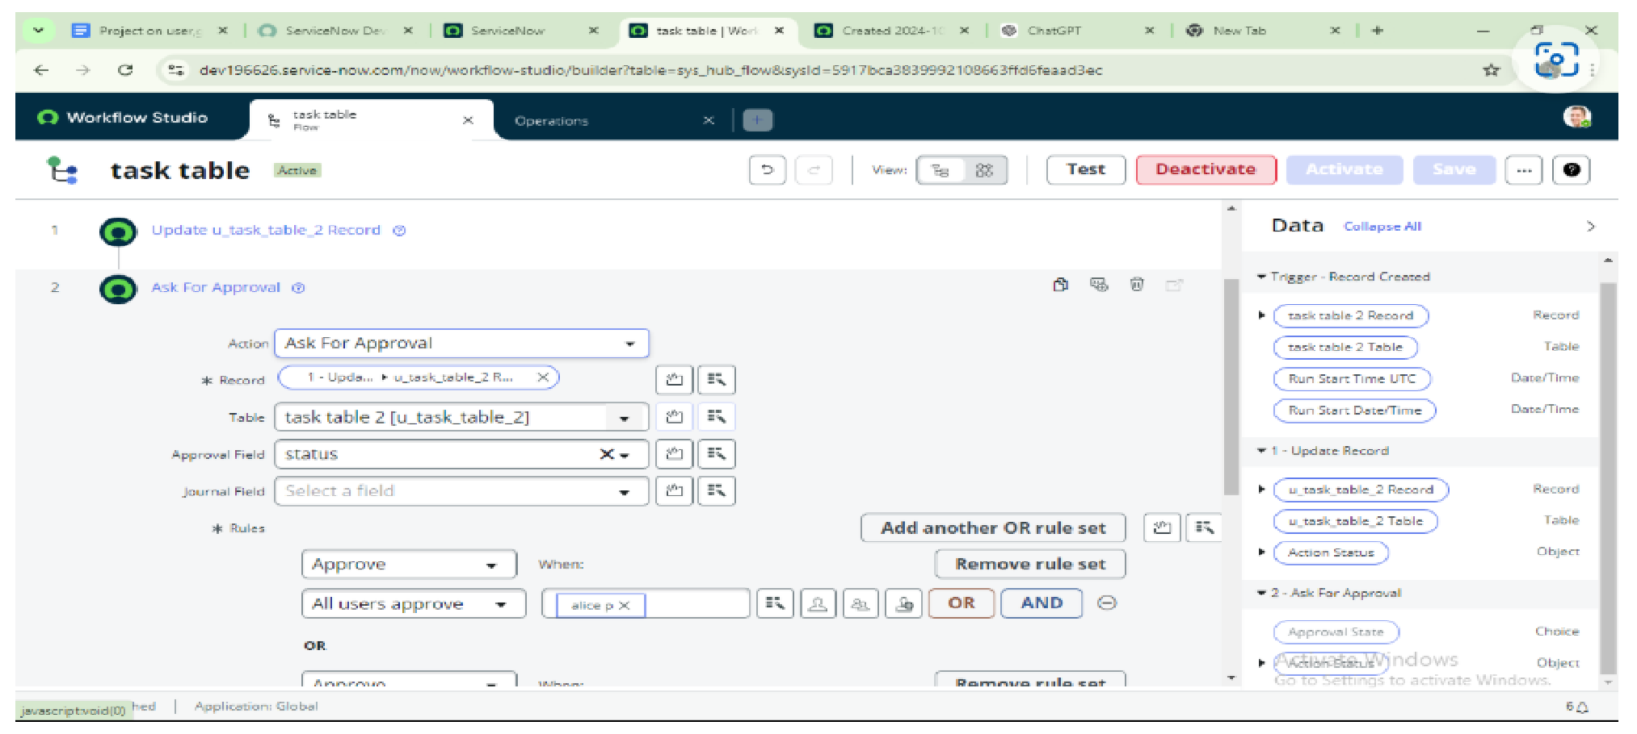

* Go to application navigator search for task table.
* It status field is updated to completed

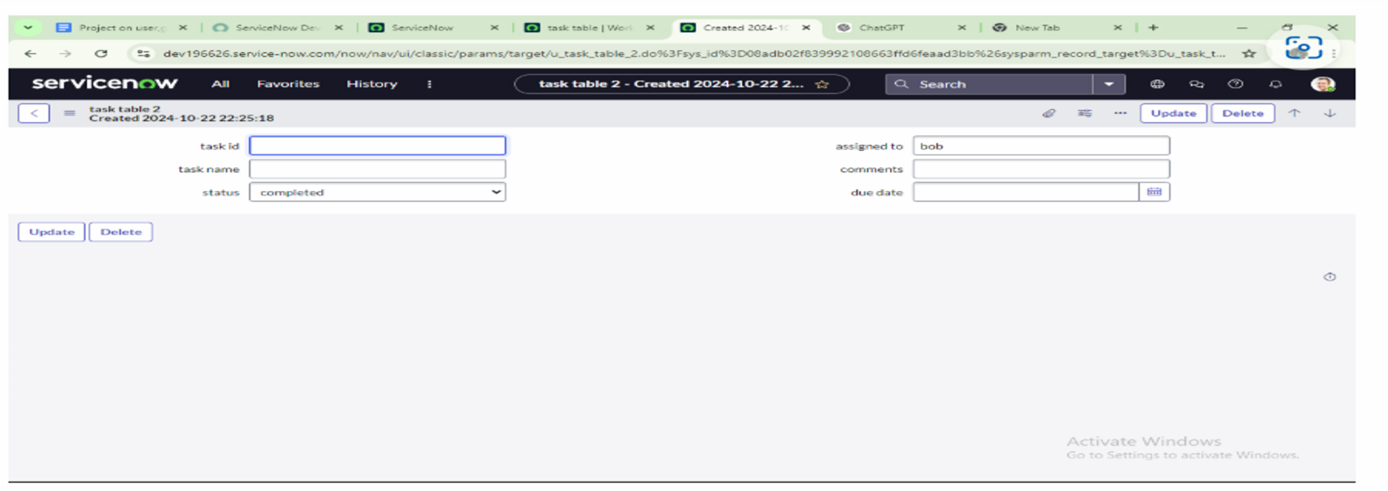

* Go to application navigator and search for my approval • Click on my approval under the service desk.
* Alice p got approval request then right click on requested then select approved

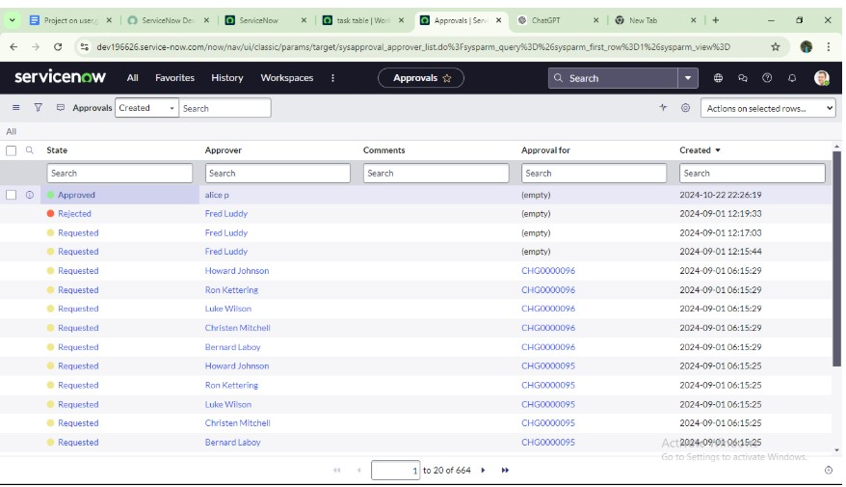

**CONCLUSION**

This scenario highlights a structured approach to project management, showcasing the roles of Alice and Bob within a defined workflow. With Alice's oversight and Bob's execution, the team effectively collaborates to ensure project success. The use of tables organizes key information, facilitating easy tracking of projects, tasks, and progress updates. Overall, this system promotes accountability, enhances communication, and leads to the successful completion of projects.